GAWDESY

GANDHIAN WELFARE AND DEVELOPMENT SOCIETY

Registration No: 11/1993

**My life is my message**

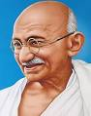

Our Service is

Key to

solve poverty

Our aim is House to House compulsory Toilet Constructions

**Regtd Office :** GAWDESY, Main Road, Karuppur, Konerirajapuram-post,

Naducauvery-Via, Thiruvaiyaru-Taluk, Thanjavur District ,

Tamil Nadu. PIN-613101

**Contact** : Phone- 04362- 283720, Mobile: 9486575506 (President),

9443383720 (Secretary)

**Email** : [gawdesy@gmail.com](mailto:gawdesy@gmail.com)

**Web Site** : www.gawdesy.org

**President’s Desk**

**Mr.A.Mavadiyan**

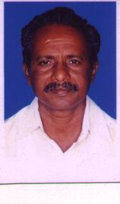GAWDESY is committed to empower the underprivileged people to attain social, physical and economical well being through enhancing their awareness towards self reliable developments and standards of quality of life. It attempts to motivate the people to set goals in their life according to their aims and desire to achieve meaningful resources for self and social satisfactions.

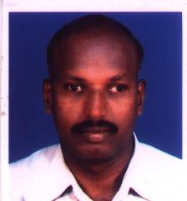 **Mr.K.Karunamoorthy** **Secretary’s Desk**

The individuals could achieve their own fruitful aims in life with blessings of god through sincere and hard work with possessing human values of Justice, straight forwardness, truthfulness, dharma, humbleness, obedience, self control, social adjustments, sacrifice, respectfulness, positive attitude, loving each other etc. It brings them whole needs fulfilled and have complete satisfactions in life.

**PROGRAMME of GAWDESY**

* Health & Sanitation
* Self Help Groups
* TB Control
* DIET Improvement
* Toilet Constructions
* School Health & hygiene program
* Income Generation programme & training
* Loan linkages with bank
* Vocational Training Centre
* NABARD Programme
* Youth Group programme
* Environmental programme
* Farmers Federations
* Prevention of Parent to Child Transmission of HIV/AIDS

**INFRA STRUCTURE FACILITITES OF GAWDESY**

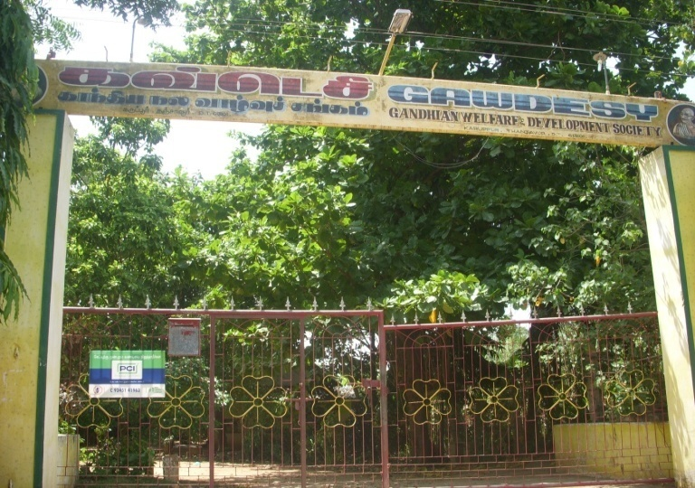 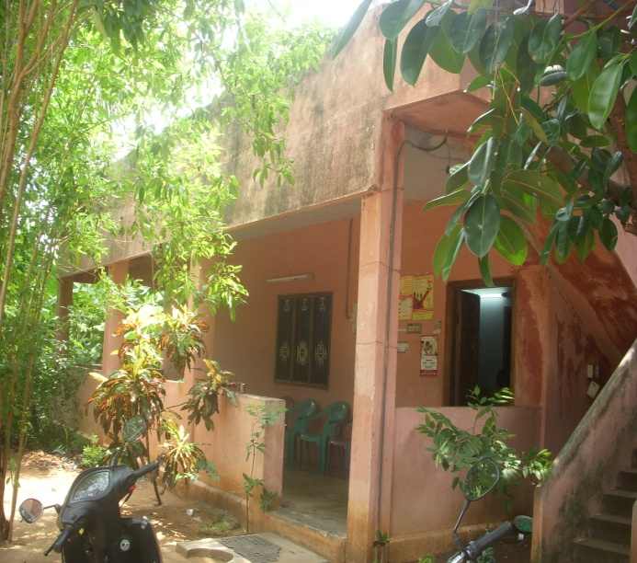

Administrative Office

Campus Entrance

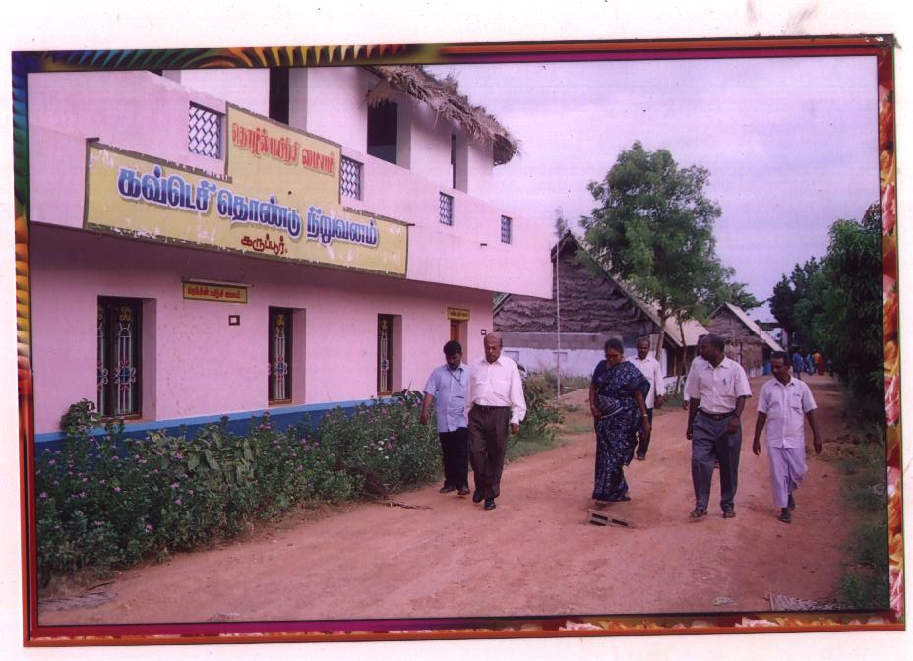

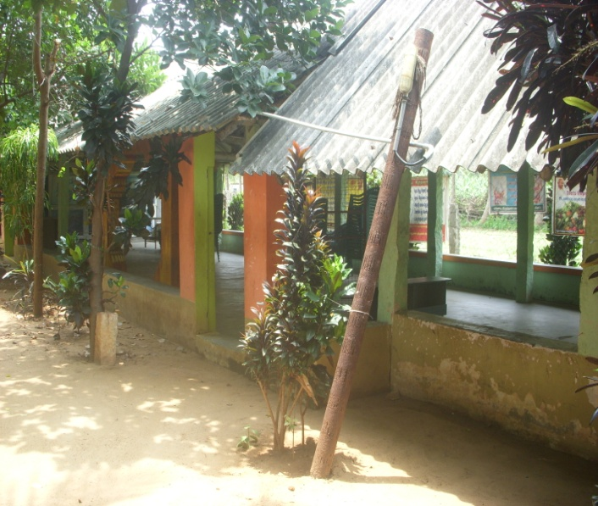

Meeting Hall

Training Centre

**Human Resources in GAWDESY**

|  |  |  |
| --- | --- | --- |
| **S.No** | **Designation** | **No of Staff** |
| 1 | Coordinator | 2 |
| 2 | Cluster Coordinator | 24 |
| 3 | Administrative Staff | 3 |
| 4 | Trainers-Vocational | 2 |
| 5 | Outreach Workers | 20 |
| 6 | Campus In-charge | 1 |
| 7 | Gardener | 1 |
| Total No of staff | | **53** |

|  |  |  |
| --- | --- | --- |
| S.No | Area | Units |
| 1 | No of District | 1 |
| 2 | No of Taluks | 9 |
| 3 | No of Blocks | 14 |
| 4 | No of Panchayat | 589 |
| 5 | No of Villages | 2260 |

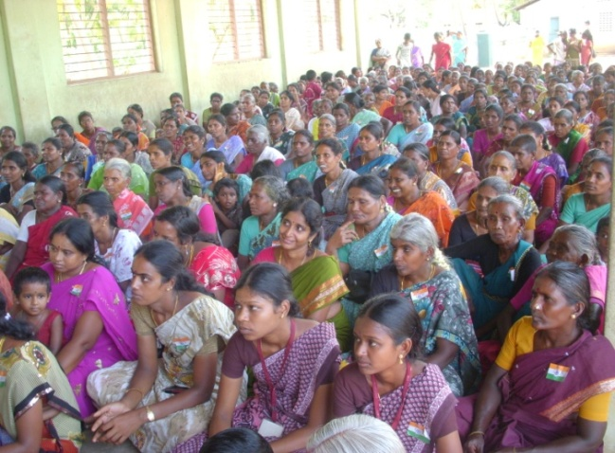

**Self Help Group Coordination Meeting**

**Activities of GAWDESY**

Once in 3 months, GAWDESY conduct the coordination meeting with the target of 600 women members and motivate them to strengthen individual and group performance through sharing of good practices with each group and finding ways to overcome from the challenges in developing strategies of socio economic activities.

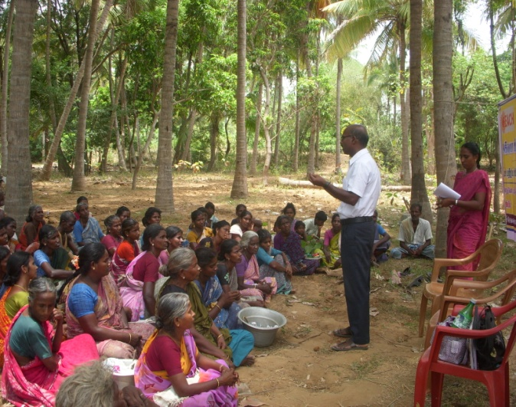

**Health Education and TB Awareness**

The organization with the motto of improving Healthy life of community, Health Education and TB Awareness programmes are being conducted and identify the TB symptomatic people and facilitate to adhere to complete TB treatment courses which would be protect the general population from TB. The programme emphasizes the needs and importance of creating TB free villages in the society. 113 TB awareness programme in 56 villages are conducted through which 83 TB symptomatic referred and tested.

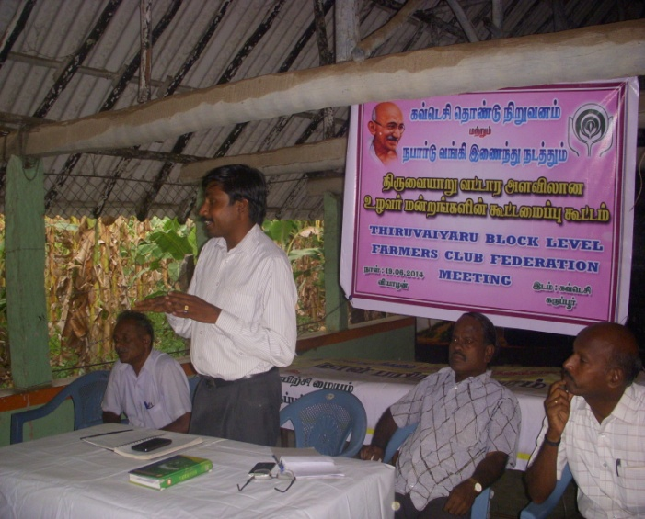**Formation & Functioning of Farmers Clubs**

GAWDESY in association with NABARD committed to support farmers to develop independently to improve their quality of life by educating on organic farming and empowering them through formation and active functioning of Farmers’ Clubs. There are 98 Farmers clubs are formed and actively functioning through the support of the organization. Dr.K.Subramanian, DDM,NABARD, Thanjavur addresses the farmers during the Club Inauguration at GAWDESY

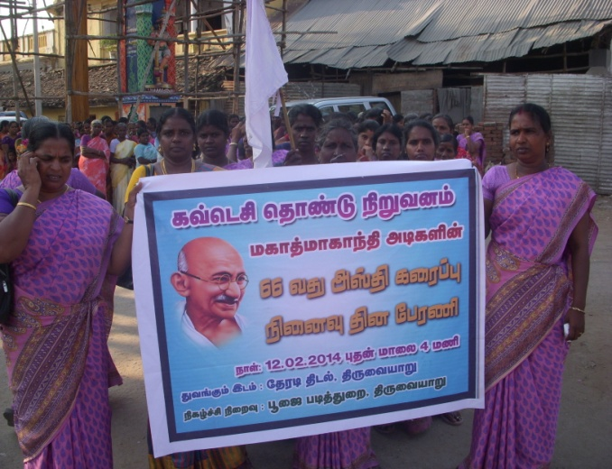**Rally on Mahatma Gandhiji’s Asthi Karaippu memorial day.**

Every year the organization observes the memorial day of Mahatma Gandhiji’s Asthi Karaippu by rally from Theradi to Pooja Mandapam at Cauvery river in Thiruvaiyaru. By the day, all the staff and beneficiaries of about 300 SHG members used to do pushpanjali to Gandhiji’s statue.

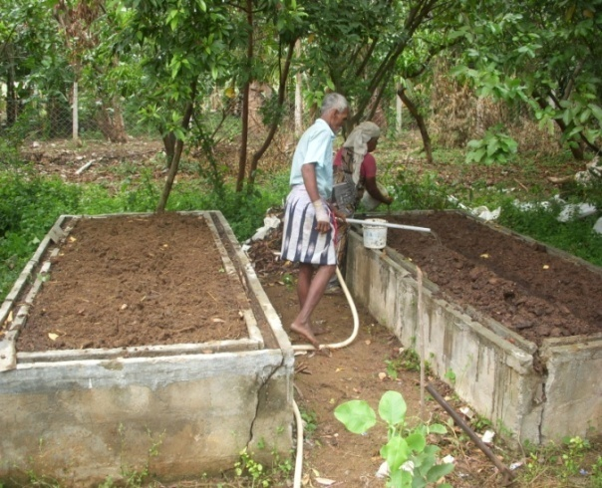 **Vermi Compose:**

The organization has splendid experience in producing and selling Vermi compose in order to strengthen the organic farming in the villages through the technical and financial support by CAPART of Hydrabad. Through this cultivation, there are about 150 farmers benefitted and concentrated on developing Organic farming.

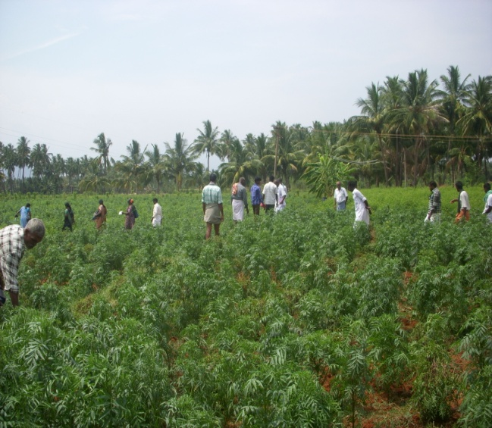

**Exposure visits for Farmers to Theni district**

The Farmers Club members are facilitated to visit for exposure to new methodologies of Agriculture and Farming technologies by the organization with the support of NABARD, Thanjavur. There are sixty members of farmers clubs from 15 villages are made to visit to Theni district and exposed for Chilli cultivations.

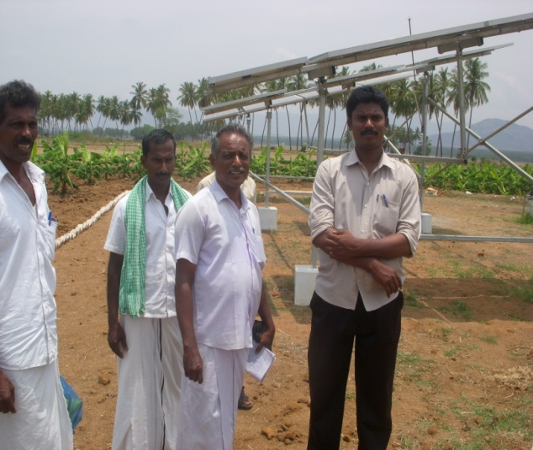

**Training on Solar Energy Conservation**

In association with NABARD, the farmers are given training on conservation of solar energy and its effective utilization in irrigation and cultivation of banana grooves and crops to save electricity. There are 87 farmers trained through the programme. The training held at Sothuparai of Theni district.

**C**

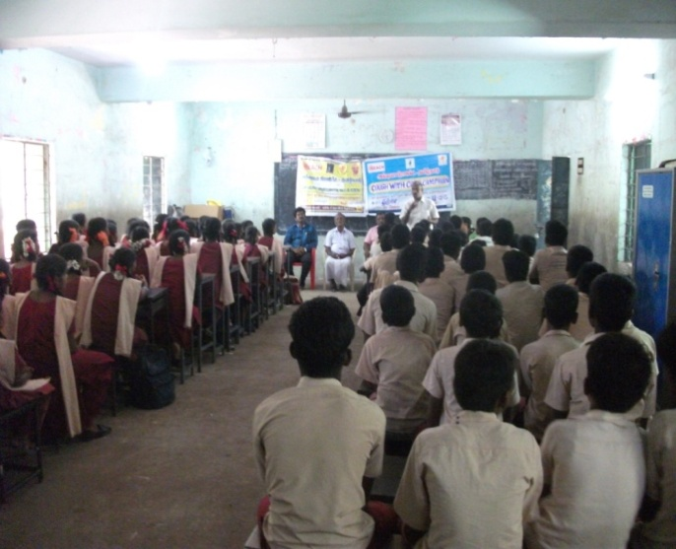**Cough with Care Campaign at Schools**

In collaboration with REACH Project Axshya, GAWDESY conducted special program of Cough with Care Campaign against TB in schools and colleges in Thanjavur. There are about 900 and 600 students were sensitized for TB prevention through cough hygiene. Drawing competitions were conducted in the schools and colleges on ‘My role on Cough with Care Campaign”

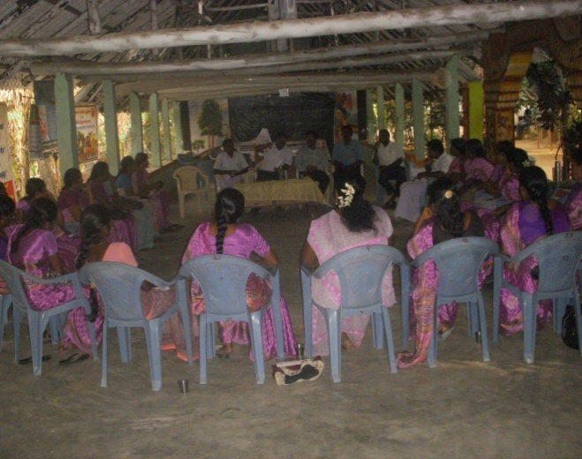**GAWDESY Staff Review meeting**

Weekly staff review meeting is conducted in every Saturday. During the meeting the individual and cluster level performance assessment will be done in the presence of President and Secretary. The progress of the activities, planned executions, gaps and challenges will be analyzed. The Upcoming week with or without revised plan of action will be prepared according to the needs and importance of activities as immediate and long term completions. The best performer of the team will be specially honored during the meeting.

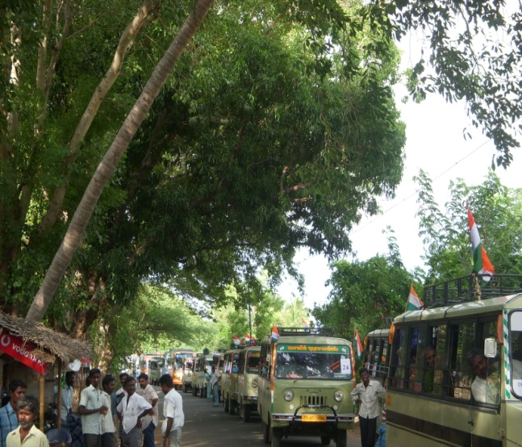**Van Rally on Independence Day**

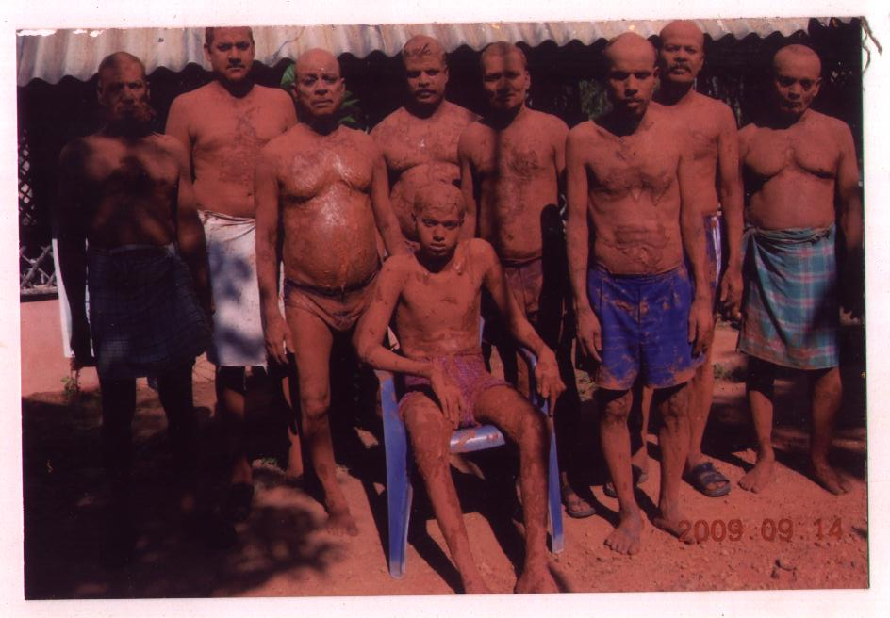GAWDESY leads sound rally performance in every Independence Day to make reinforcing Gandhian philosophies and thoughts to the community. The rally includes the people of Self Help Groups, Farmers Clubs and Youth Groups and used to go around the blocks of Thiruvaiyaru and Budalur blocks of Thanjavur district. About 1000 participants would be contributed to hoist the National Flag in every village of the above said blocks.

**Traditional way of treatments.**

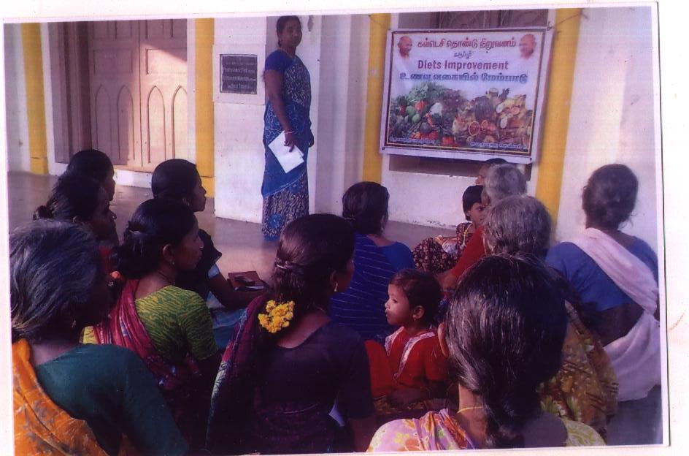GAWDESY focuses to support strongly to develop traditional means of treatments such as Soil bath which benefits the people to extract toxics from the body and protect them from diseases like diabetic control, hypertension, bone illness, skin diseases, etc. There were 65 people are undergone such treatment till now.

**DIET Awareness & Demonstration program**

The target people of Adolescence girls, ANC & PNC mothers & children in the age group of 0-12 years old are focused for the program and sensitize them for in taking Balanced Nutritional food includes indispensable fruits and vegetables. Every month one program for each 22 villages will be conducted.

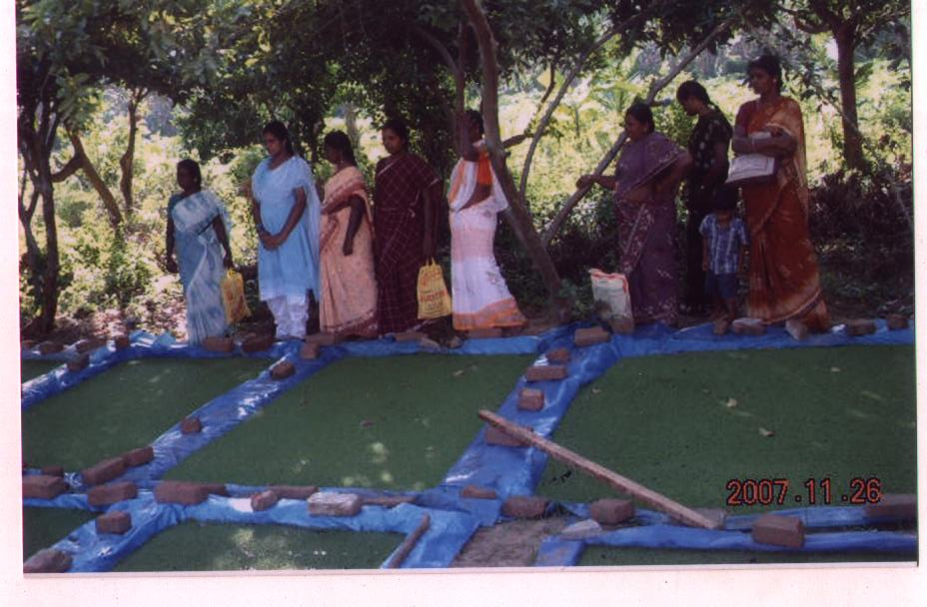 **Training on Asola for cow rearers**

There are about 500 cow rearers given training on Asola food preparation at GAWDESY through which the advantages of Asola to the cows and cost effective health products contained in it were sensitized to the target communities. The outcome of the training showed interest of about 230 people involved in such process and benefitted out of it.

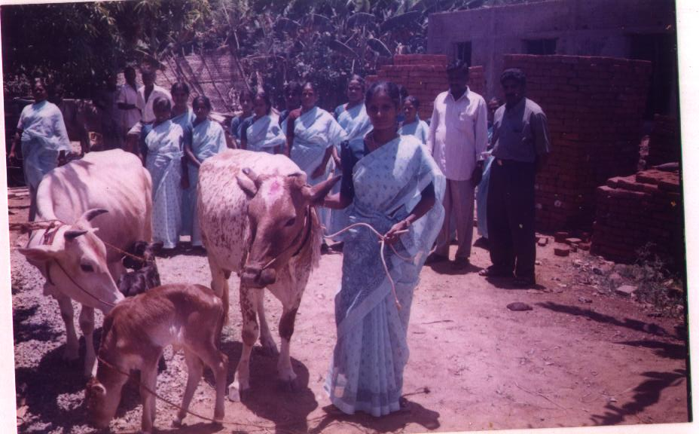 **Support of Livestock to SHG members**

There were 6052 cows as two for each SHG member through Bank loans with DRDA and TAHDCO with the subsidiary provided. Totally 3026 SHG members were benefitted out of such services.About 12000/- litres of milk produced and supplied to VKA Diary unit of Karur district. The technical support of maintenance of Cows in an appropriate manner were given to the cow holders through various trainings in association with Mahilar Thittam.

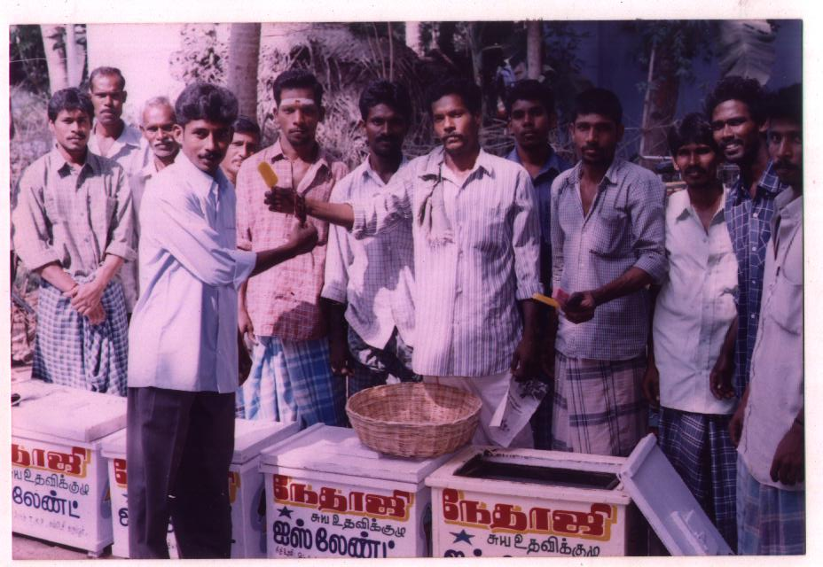**Support to Men SHGs**

GAWDESY never forget men for strengthening their Socio economic status as a results, they were supported through Bank linkages with subsidiary on DRDA schemes, 20 members together provided with establishment of Nethaji Ice Company, 20 members of a SHG provided with Selling Vessels and for 15 members with Bamboo products.

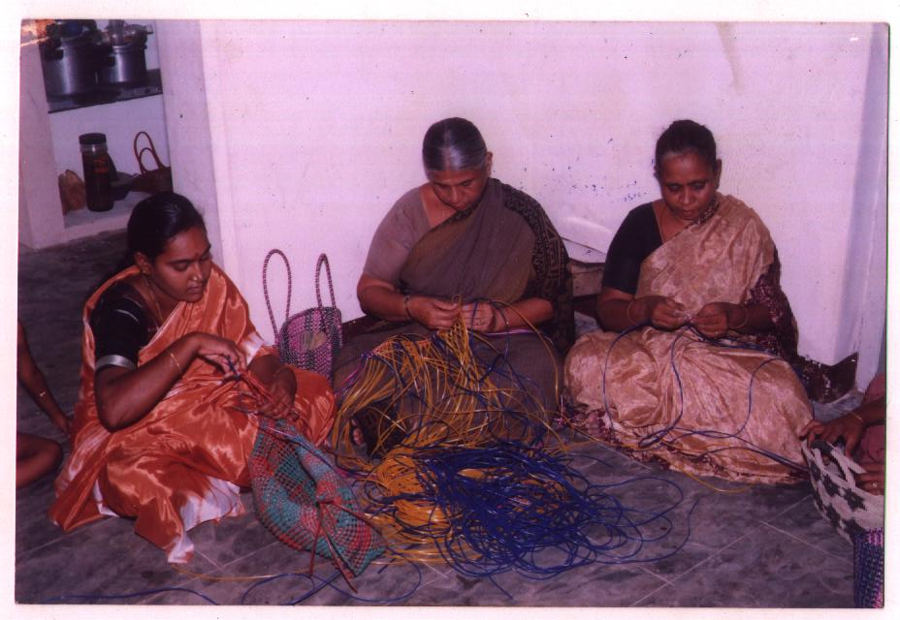

**Training on Wire Bag Making**

There were 240 SHG women of 65 villages given training on Wire & leather bag making with the support of NABARD. Out of them,216 women started earning with the average of Rs.4000 per month.

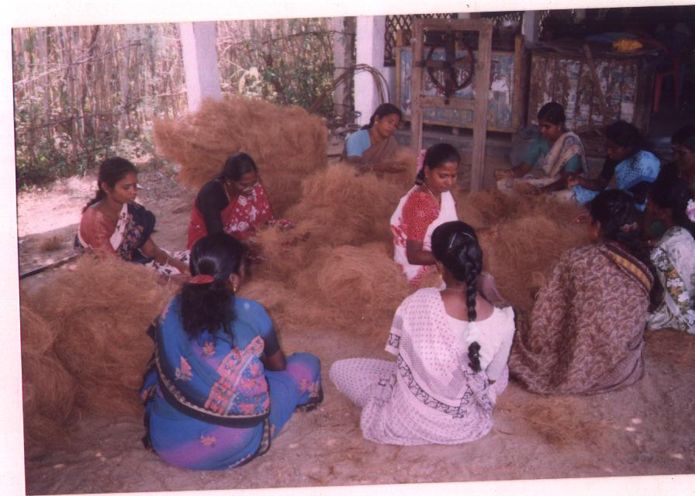**Training on Coir and Foot Mat making**

There were 312 SHG members were trained and made involve in Coir making & foot mat business in association with Mahalir Thittam, DRDA and TADHCO in GAWDESY. Out of Trained, 85 women involved in such business and started earning of Rs.7000 - Rs, 8000 per month.

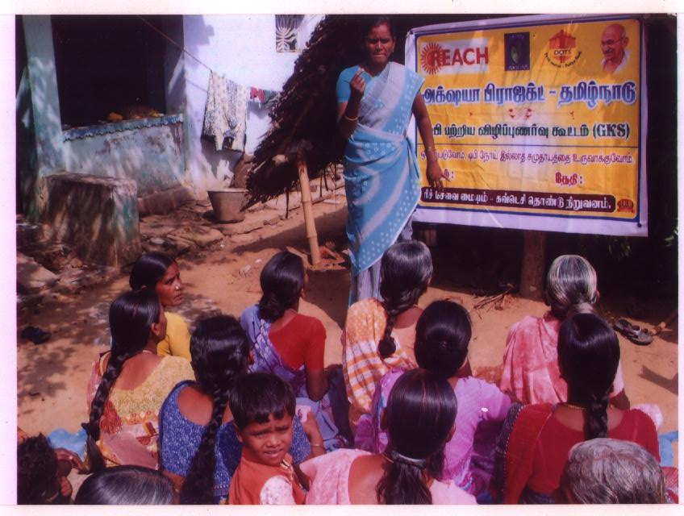

**Awareness Program on TB among Rural people.**

In association with REACH, Chennai through Axshya project, awareness on Tuberculosis are being done in rural areas in Thiruvaiyaru, Thanjavur, Budalur and Papanasam blocks. Through the program 2350 rural men and women were covered and facilitated to access to RNTCP services.

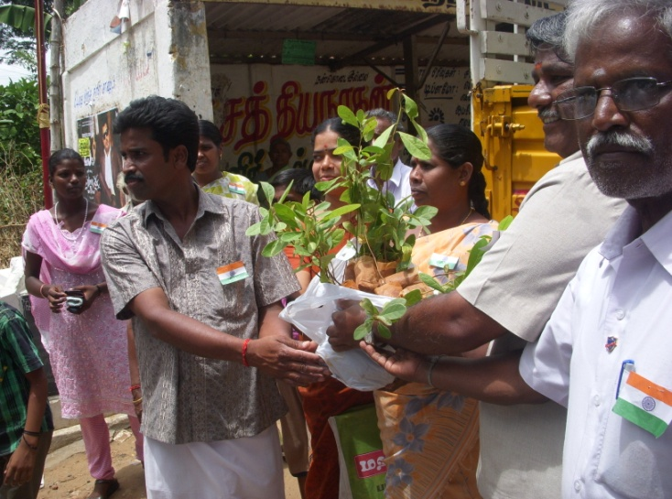

**Tree Samplings distribution during Independence Day.**

During the Independence Day,2014, GAWDESY distributed 6500 Tree Plantation samplings to the community people of SHGs and members of Farmers Clubs in and around villages of Thieruvaiyaru & Budalur blocks.

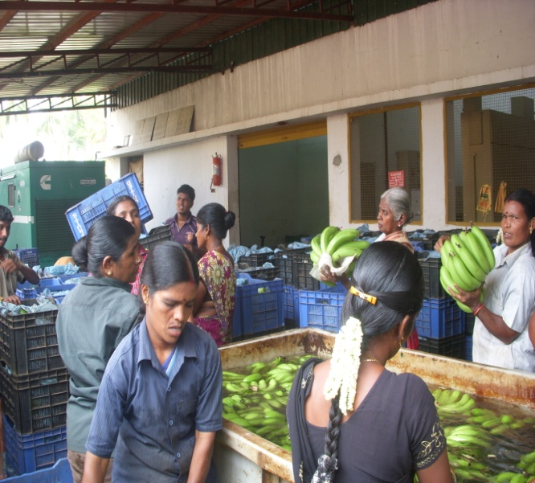

**Exposure visit for Farmers Clubs**

GAWDESY with the support of NABARD facilitated the 52 members of Farmers Clubs along with organization staff to Banana Exports Company at Chinnaalapattu in Theni District. The farmers are exposed to the quality and quantity based cultivation of Bananas and maintenance by using advanced technical methods.

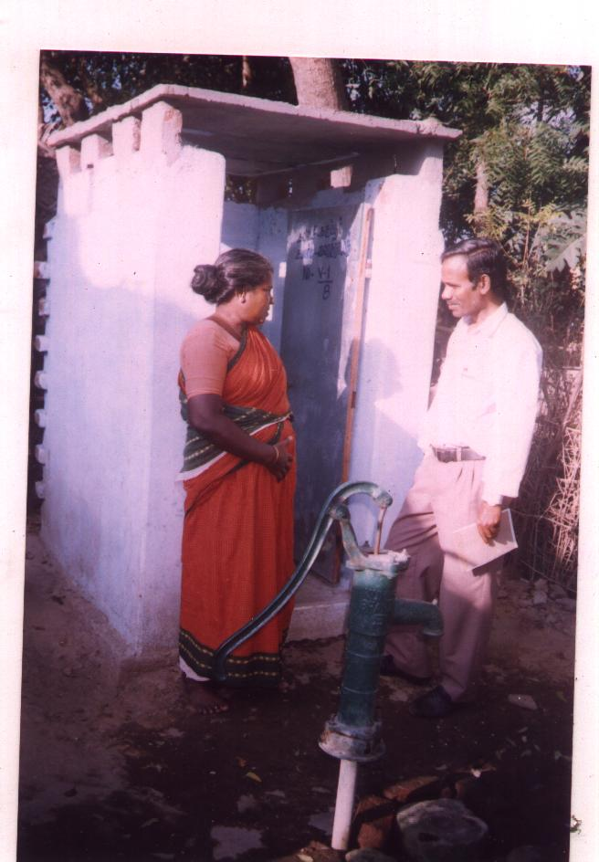**Toilet Construction and Evaluation**

GAWDESY with the support of CAPART, Hydrabad constructed 200 low cost toilets in 200 households of 10 Villages at Thiruvaiyaru block in Thanjavur district. Each toilet is being used by 3-5 members of the houses. They are also sensitized about the pre & post usage of toilet and maintenance of Hygiene surrounds the toilet

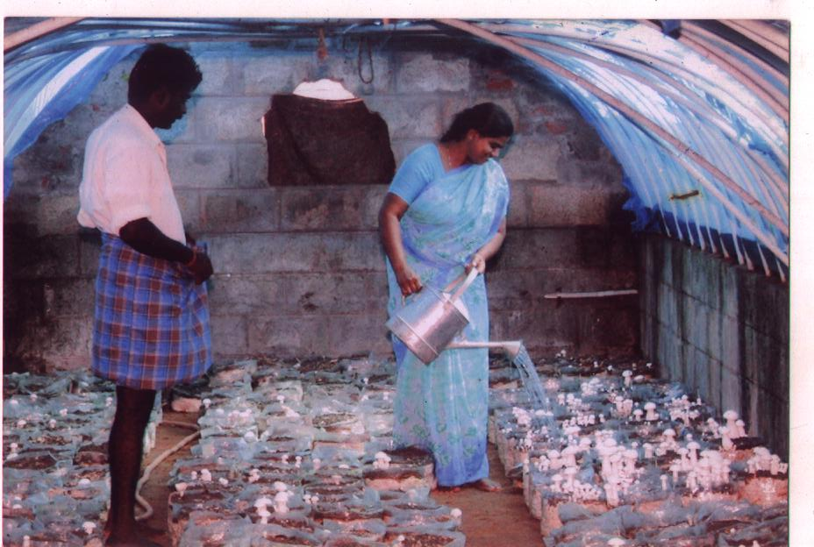**Milk Mushroom Cultivation**

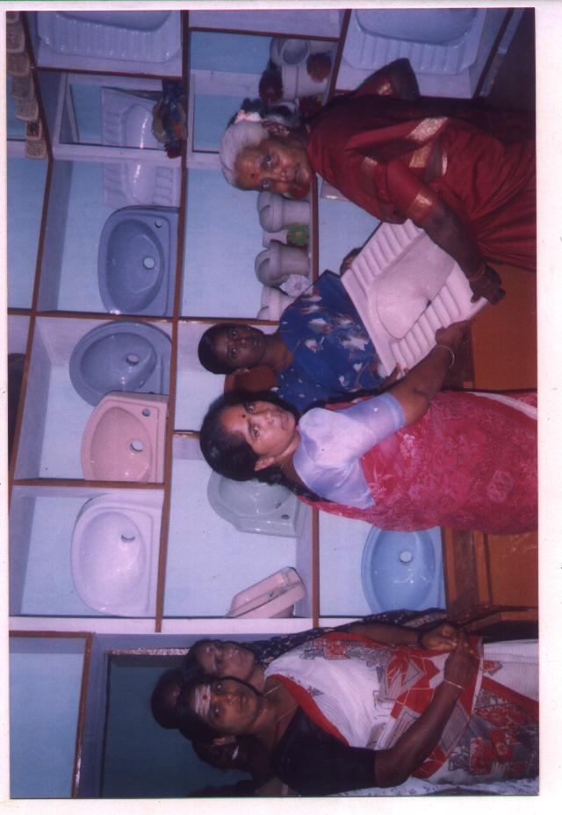GAWDESY through SHG named Puduthamil promoted the cultivation of Milk Mushroom in Vilar Panchayat village of Thanjavur district with the support of State Bank of India loan Rs. 5, 00,000/- with the DRDA subsidiary of Rs.1,25,000/-.The SHG members benefitted in large extend for their socio economic development by selling in Uzhavar Sandhai as demands increased.

**Establishment of GAWDESY Sanitary Mart**

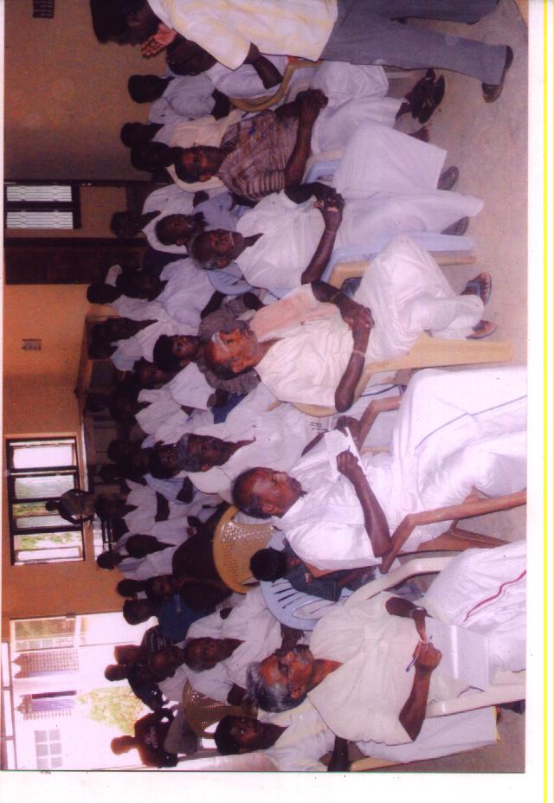GAWDESY established a Sanitary Mart in Thirukkattuppalli of Thriuvaiyaru block. The Mart was supported by DRDA Thanjavur for about Rs.2, 00,000/-. The mart with all the advanced design toilet materials helped the community to purchase at production cost which promoted new toilets constructions in the surrounding villages and promoted Health and Hygiene among the poor socio economic classes of the community.

**Farmers Training on Organic farming**

GAWDESY with the support of NABARD, Trained 209 farmers club members of Thriuvaiyaru and Budalur blocks in 5 Batches on Organic farming and utilizing solar Energy in Agriculture usages.

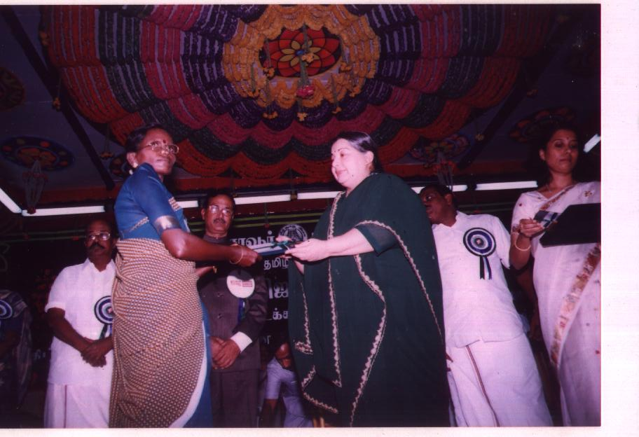

**Honors of GAWDESY Services**

**Service received from Hon. Chief Minister**

Honorable Chief Minister of Tamil Nadu, Selvi.J.Jayalalitha handing over the Bank loan cheque to one of the GAWDESY Muthamil SHG members of Ammayagaram village of Thiruvaiyaru Taluk , Thanjavur district during the Mahalir Thittam program of loan support services to selective members of SHGs held at Thanjavur.

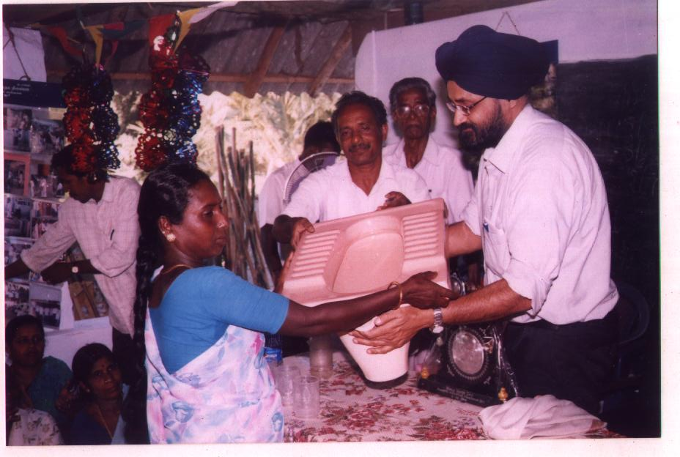**World Water Day program at GAWDESY**

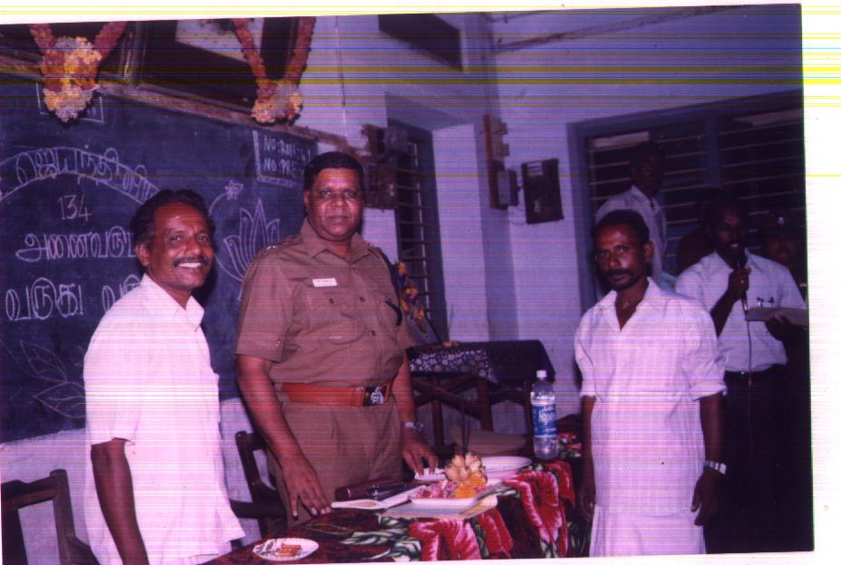GAWDESY has its interest to observe World Water day for every year in which 2000 and above women would be participated. Mr.Dipeender singh, country representative of Water Aid , New Delhi has participated as guest honor during the program held in the year of 2010 and distributed Toilet materials to rural people those who successfully underwent Training on Water, Health & Sanitation and contributed effectively in their villages.

**Gandhi Jayanthi Program**

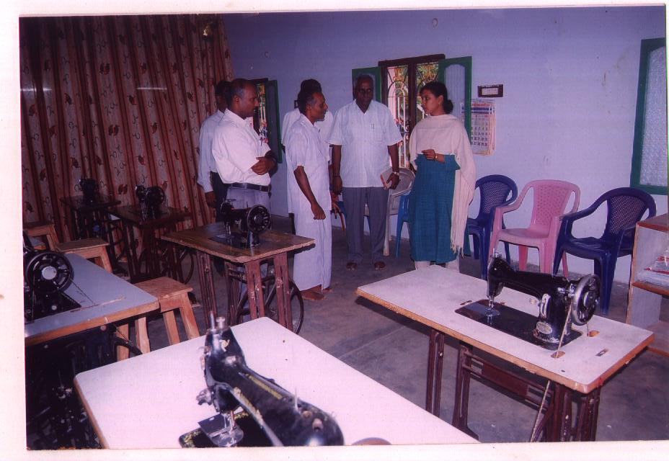During one of the yearly programs on Gandhi Jayanthi at GAWDESY on 2nd October, 2012 Shri. Mr. Tirugnanam I.P.S Director Inspector General of Police participated as Guest of Honor and shared his views on Gandhian principles and thoughts. There were about 250 men SHG members participated in the program.

**Executive Director,Women Development Corporation.**

Shri.Mrs.P.Amutha I.A.S, Executive Director, Tamil Nadu Women Development Corporation, Chennai visited Vocational Training Centre of GAWDESY along with Mr.Rajamallaiyan, Project Officer Mahalir Thittam, Thanjavur. The Visitors appreciated very strongly the organization for its splendid contributions towards women socio –economic developments in the district.

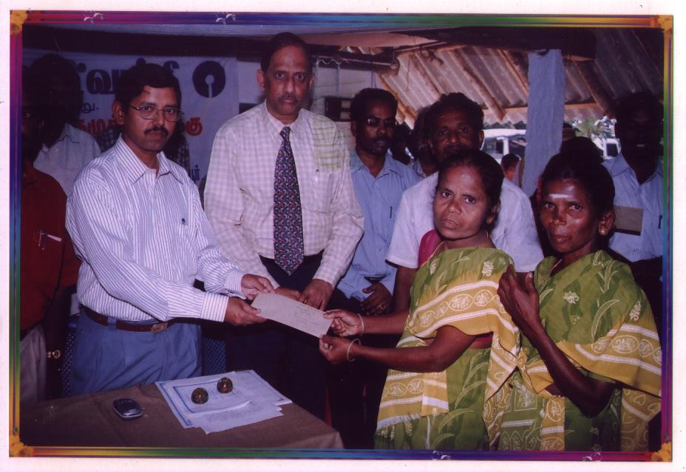**SHG Loan Mela**

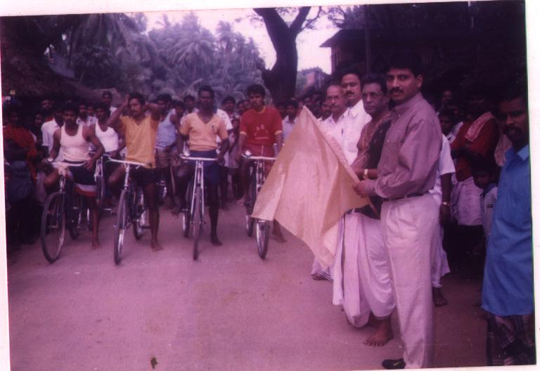Shri.Mr.Veerashanmugamani I.A.S. District Collector participated as Guest of Honor in Loan Mela organized by GAWDESY in association with State Bank of India and distributed loans to SHGs. There were about 1600 women SHG members participated and benefitted on 1 crore of rupees.

**Sports Events Inauguration**

Dr.K.Jayanth Murali I.P.S , Superindent of Police, Thanjavur district has inaugurated Fast Cycle competition conducted by GAWDESY at Karuppur. There were 27 youth have participated actively and made the event as grant successful.

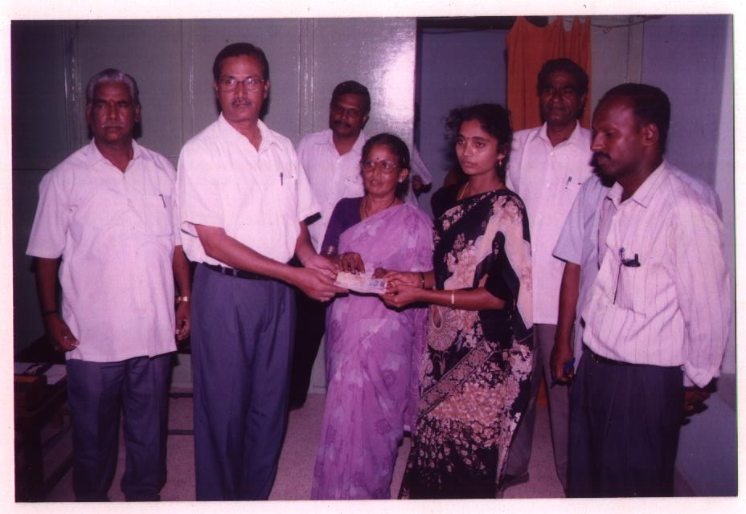

**Loan distribution and felicitation by District Collector, Thanjavur.**

Shri.Mr.Kosalaraman I.A.S, District Collector of Thanjavur participated and distributed revolving funds to SHGs at GAWDESY in collaboration with Indian Bank and State Bank of India. He motivated the loan beneficiaries and participants towards developmental activities for improving socio economic status of women.

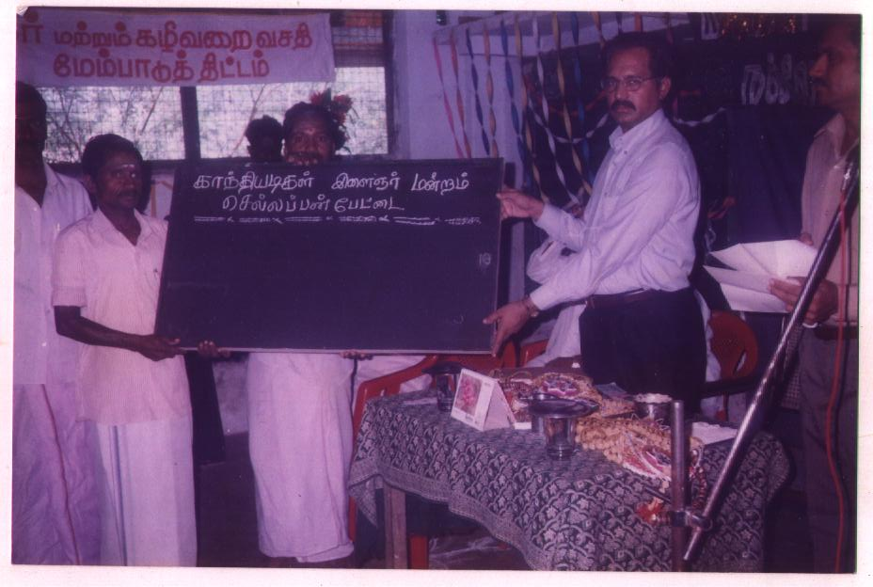**Men SHG Name Board Installation**

Shri.Dr.M.Rajaram, I.A.S District Collector of Thanjavur hand-over the Name board to 27 men SHGs at Pudupatti Village, Budalur block of Thanjavur district. The program was organized and coordinated by GAWDESY held in the year **2002**.

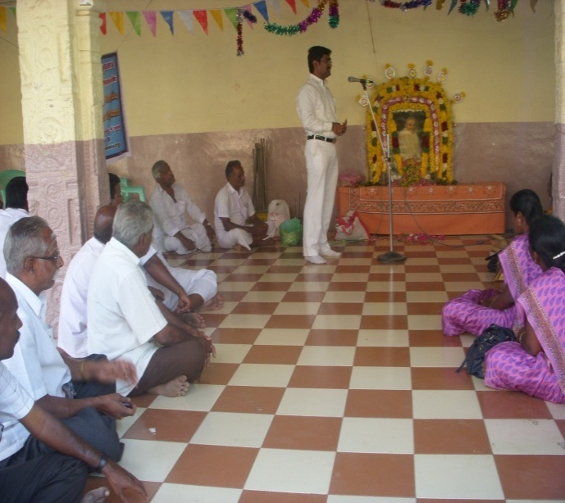**Mahatma Gandhiji’s Asthi Karaippu memorial day** **conference**

Mr.G.Manikanda raja Judicial Magistrate, Thiruvaiyaru Jurisdiction has participated and appreciated the remarkable commitments of GAWDESY during the Asthi Karaippu memorial day. The officials of Sarvodhaya Mandal, 750 SHG members were participated and observed the day. About 1500 Tree samplings distributed to all the participants.

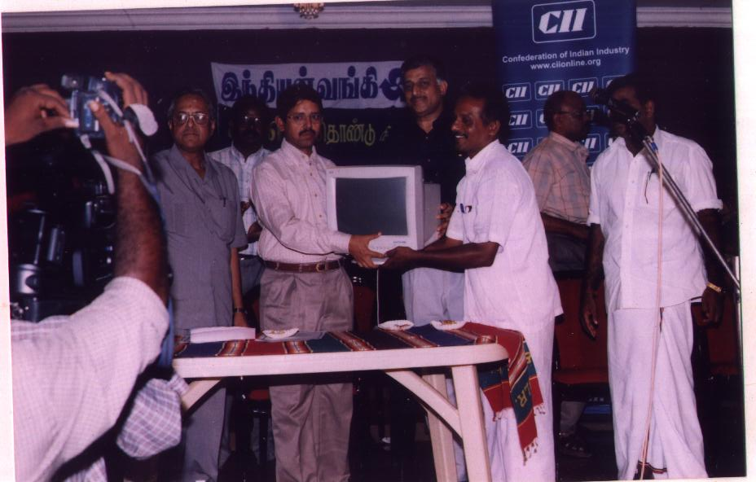**Contribution by Confederation of Indian Institute ( CII )**

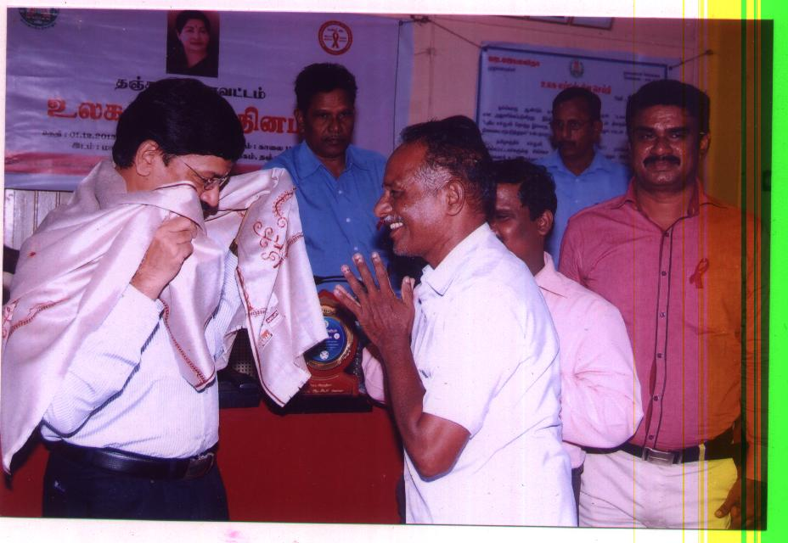Mr.Kannan, CII Chairman of Trichy Region has contributed Desktop computer and accessories to GAWDESY for its valuable Socio-Economic services towards women and rural developments in Thanjavur district through Shri.Mr.Veerasanmugamani, I.A.S, District Collector of Thanjavur and recived by Mr.Mavadiyan, President of GAWDESY.

**World AIDS Day Program**

Mr.Mavadiyan, President of GAWDESY honoring Shri.Dr. Subbaian, District Collector of Thanjavur during the program of World AIDS Day,2014 held at Collectorate. There were 40 staff of GAWDESY participated in the program .

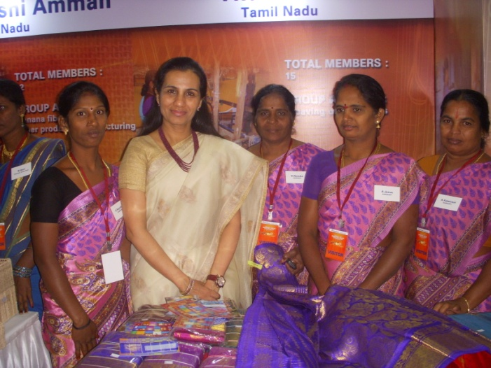**World Women’s Day Program,2014 at ICICI.**

GAWDESY SHG members and staff were participated in World Women’s Day program, 2014 held at Headquarters of ICICI Bank,Mumbai. Shrimathi .Chantha Kochar ,Managing Director of ICICI appreciated contributions being made by GAWDESY and Team towards Socio-Economic developments of poor rural women. Stall with 150 silk sarees has kept for views and sold by SHGs of GAWDESY.

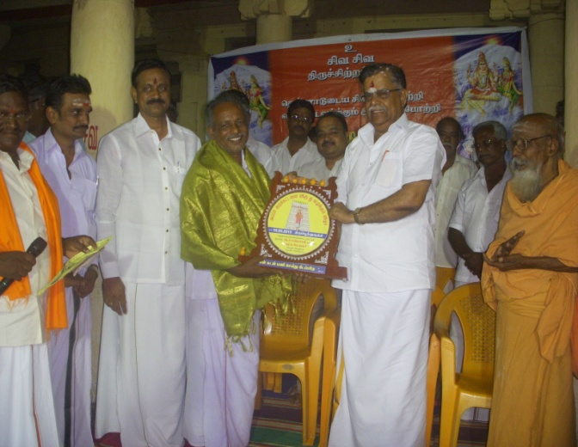**Award Function**

GAWDESY received Best NGO for Social Work development announced by Appar Trust at Melathirupoonthuruthi Thanjavur from Mr.L.Ganesan, Member of National Executive Committee of Barathiya Janatha Party (BJP). The Award received by Mr.A.Mavadiyan President of GAWDESY .NGO.

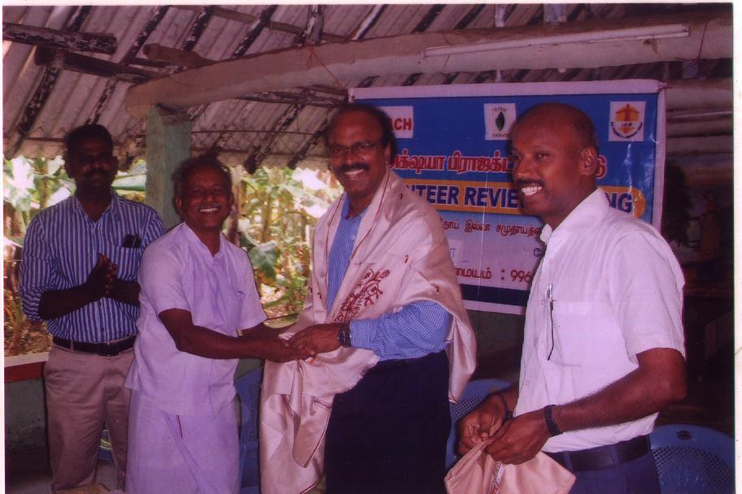**REACH Project Axshya Review Meeting with DD-TB**

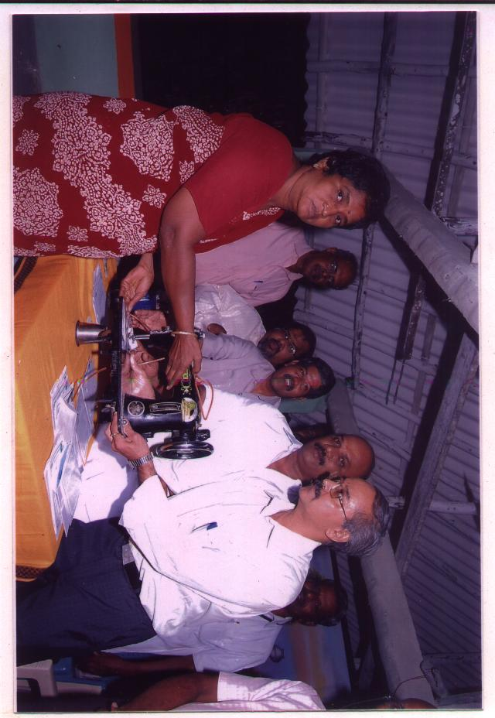GAWDESY supported by REACH Project Axshya for TB Awareness and control has conducted Community Volunteers meeting in which Dr.V.D. Murugesan, Deputy Director, Tuberculosis, Thanjavur has participated and appreciated the staff for their valuable contributions towards TB Awareness and control in Thanjavur.

**Supplying Sewing Machines to SHG members**

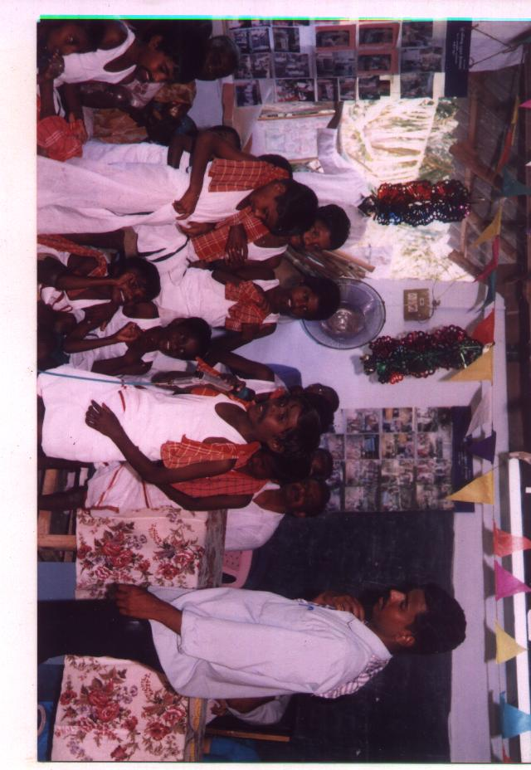GAWDESY with the support of ANARDAY Foundation provided 565 sewing machines to SHG members on installment basis of payment for Rs.4000/-per machine. Mr.S.T.Ravikumar DDM, NABARD Thanjavur participated and handed over the machines to the beneficiaries in 2012.

**Cultural Programme on Health and Sanitation**

GAWDESY promoted awareness on Health and Sanitation in villages by formation of cultural teams of various groups in villages, schools, youth clubs and SHGs. The School boys of Anthali Govt Primary School conducted the awareness programme.